**DAILY ONLINE ACTIVITIES SUMMARY**

|  |  |  |  |  |  |  |  |  |
| --- | --- | --- | --- | --- | --- | --- | --- | --- |
| **Date:** | **26-05-2020** | | | | | **Name:** | **Huda Sultana** | |
| **Sem & Sec** | **8 A** | | | | | **USN:** | **4AL16CS039** | |
| **Online Test Summary** | | | | | | | | |
| **Subject** | | **BDA** | | | | | | |
| **Max. Marks** | | **40** | | **Score** | | | **28** | |
| **Certification Course Summary** | | | | | | | | |
| **Course** | **Online Ethical hacking course** | | | | | | | |
| **Certificate Provider** | | | **greatlearning** | | **Duration** | | | **40min** |
| **Coding Challenges** | | | | | | | | |
| **Problem Statement:**   1. **Write a program in C to print all permutations of a given string using pointers** | | | | | | | | |
| **Status: Solved** | | | | | | | | |
| **Uploaded the report in Github** | | | | | **Yes** | | | |
| **If yes Repository name** | | | | | **Hudasulltana/online_coding** | | | |
| **Uploaded the report in slack** | | | | | **Yes** | | | |

Online Test Details: (Attach the snapshot and briefly write the report for the same)

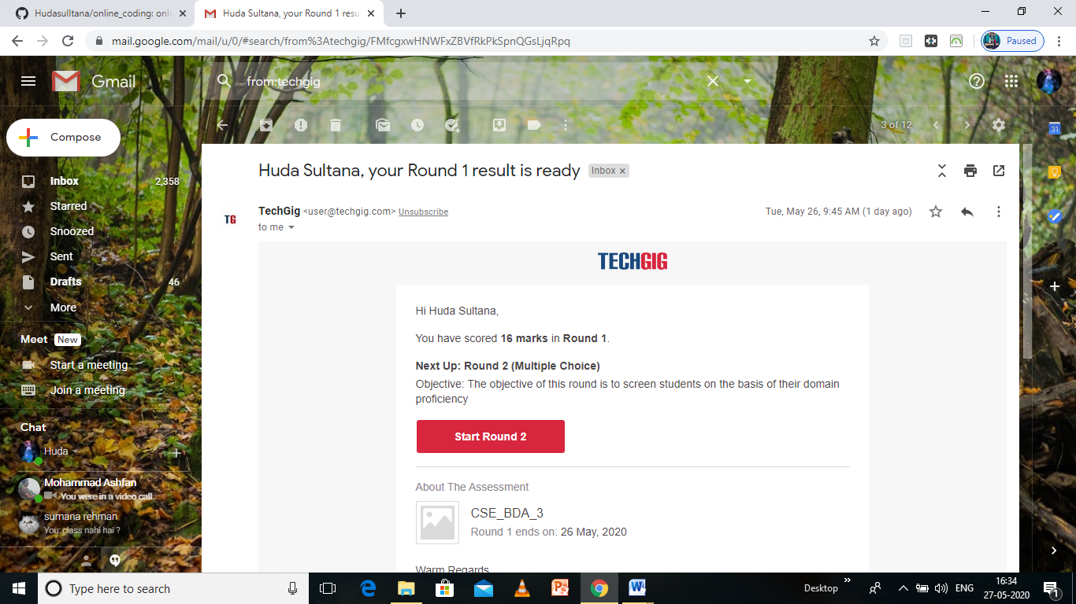

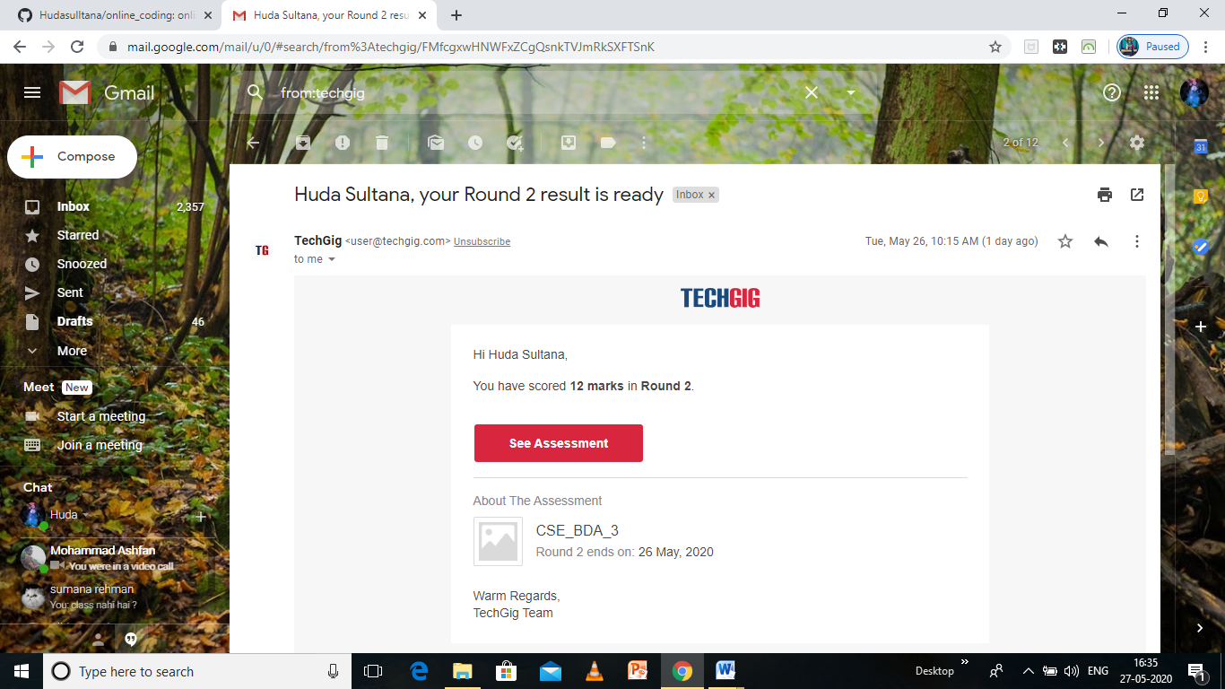

Certification Course Details: (Attach the snapshot and briefly write the report for the same)



Coding Challenges Details: (Attach the snapshot and briefly write the report for the same)

**PROGRAM 1 .**

**// Write a program in C to print all permutations of a given string using pointers**

**#include <stdio.h>**

**#include <string.h>**

**/* Function to swap values at two pointers */**

**void swap (char *x, char *y)**

**{**

**char temp;**

**temp = *x;**

**\*x = *y;**

**\*y = temp;**

**}**

**/* End of swap() */**

**/* Function to print permutations of string */**

**void permute(char *a, int i, int n)**

**{**

**int j;**

**if (i == n)**

**printf("%s\n", a);**

**else {**

**for (j = i; j <= n; j++)**

**{**

**swap((a + i), (a + j));**

**permute(a, i + 1, n);**

**swap((a + i), (a + j)); //backtrack**

**}**

**}**

**}**

**/* The main() begins */**

**int main()**

**{**

**char a[20];**

**int n;**

**printf("Enter a string: ");**

**scanf("%s", a);**

**n = strlen(a);**

**printf("Permutaions:\n");**

**permute(a, 0, n - 1);**

**getchar();**

**return 0;**

**}**